IITK CONSULTING GROUP



**End Term Project**

Project Title

Developing Market Strategies For Rapido

Submitted By:  
Prerna Singh Chauhan 210767  
Sneh Omer 211041

Mentor: Shreyansh Agrawal

**Abstract**

Rapido is a supplier of bike taxi services that links passengers with drivers for short drives. It is essentially a bike taxi version of Uber that is far less expensive and more useful during Bengaluru's horrifying rush hour. There are many reasons to choose Rapido Rides and arrive on time with affordable charges and effectively because they are India's largest Bike Taxi service provider and are available in more than 11 urban regions. Rapido was established by IIT graduates Aravind Sanka, Pavan Guntupalli, and Rishikesh SR in November 2015. Investors in Rapido include Pawan Munjal of Hero MotoCorp and Rajan Anandan, a former head of Google India. Rapido competes with other businesses by offering the lowest fares, and it offers promotional codes to all of its customers so they may save more money and enjoy other benefits. Additionally, it provides an opportunity for bike owners (with a valid driver's license) to use the platform as a rider and earn extra money in their spare time. Their overarching goal is to innovate reliable commuting for everyone, right outside your house. combining exceptional potential with troublesome development. Our obejctive behind the comprehensive study is to understand the true potential of bike-taxi future in India and to comprehend the position of Rapido in this market. We would also try to plot some major improvements, strategies, and new product for Rapido to help it secure the future in India.

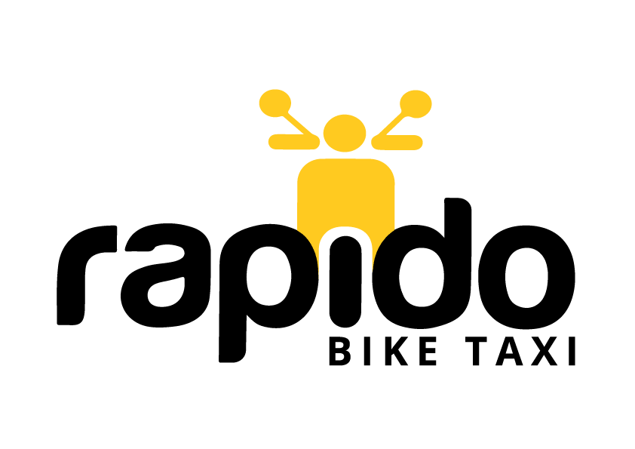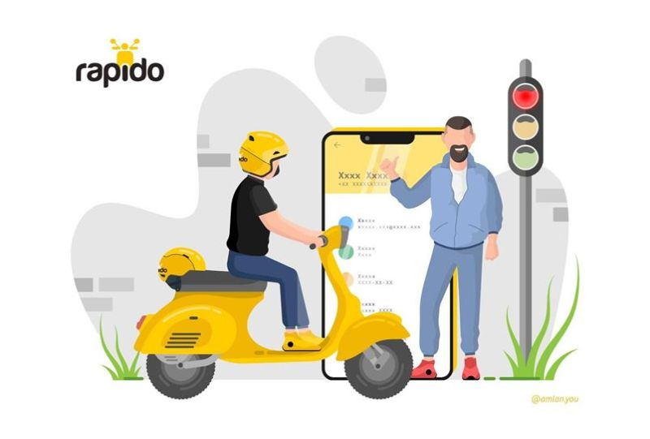

**Bike-Taxi Market**

The bike taxi market is currently valued at $50 million in 2021, and is expected to grow upto $1,478 million by the year 2030, regustering a CAGR of 48.5%. Factors such as increased trend of on-demand ride hailing services, surge in traffic congestion in cities, and rise in demand for first and last mile connectivity are expected to drive the growth of the bike taxi market. However, legal issues associated with bike taxi and resistance from local public transport operators restrains the market growth. Still the segment is projected to offer huge growth prospects for the market players.

With the rise in demand for economical commute rides on a daily basis, it is evident that companies which can offer a great product which helps customers save money will be a promising area to venture into.

**Introduction**

Rapido was founded in 2015 and is a Bengaluru, India-based online bike taxi company. It operates in over 90 urban locations across the country and has the vision to resolve last-mile network problems. According to sources from September 2018, this bike taxi start-up has more than 15,000 enrolled riders, with daily average rides of 30,000. Aravind Sanka, a fellow founder of Rapido, claimed that the company had created more than 500,000 jobs in India as of 2019. The organization claimed to have one crore clients in November 2019.

Being able to track everything online makes travelling quite safe, even at night. Finally, there is only a two-wheeled taxi that will take you from one location to another and drop you off at the same location. According to the group, 10% of its clientele are women and 85% of its services come from return customers. As on-demand bike taxi administration is reportedly an intriguing business, Rapido has had tremendous market growth. The company is also more trustworthy because it adheres to stringent controls and strict penalties to ensure safe shipping.

Currently, Rapido is India's largest platform for bike taxis, operating in 50 major areas and providing more than 200K trips each day. The bike taxi is the future of urban mobility, and this start-up is prepared to scale to provide 1 million trips daily by 2020. They have a collection of motivated people, substantial funding, and solid initiative. All of us would be able to relate to how awful traffic is, and we should address it. Two-wheelers are the main focus, although four-wheelers are pervasive in ride hailing. Rapido is distinguishing itself and achieving syndication like status in this field where various participants are clashing or falling apart.

**Business Model**

The main goal of Rapido Bike Taxi's strategy is to provide its customers with the greatest and most satisfying services possible. They achieve this by providing their passengers with smart and secure journeys.

Customers can schedule a ride through the app, and the captain, the rider, will then arrive at the user's location. The distance that each rider should travel determines how quickly it will proceed. The people who should serve as captains should apply through the Rapido captain website and be approved by submitting the required documentation, as previously mentioned. Captains may ride anything, including bicycles and scooters.

India requires Rapido as a remedy. Its main theme is moderation. For a single traveler, a cab or autorickshaw is just wasteful. They have a similar strategy to Uber and Ola. They provide a stage in exchange for a percentage of the toll payment. According to government statistics, there are over 154 million registered bikes in India, which is several times more than there are four-wheelers. We acknowledge that the best solution to our driving problems may be a bike ride-sharing network. Transport in India may eventually transition to bike ridesharing. We are a reliable, rapid, and inexpensive drive alternative for users. We provide our users with protection on every voyage. For Riders: We provide a motorcycle owner who travels alone with a second source of income. Additionally, we offer insurance options for our riders.

Rapido’s revenue model has 2 major aspects – customer commission and B2C commission

In the commission based, Rapido charges 20% of the total fare. Rapido earns via B2C logistics by helping businesses deliver their commodities (Ex-Swiggy, Myntra, Eat.fit, Delhivery, etc.)

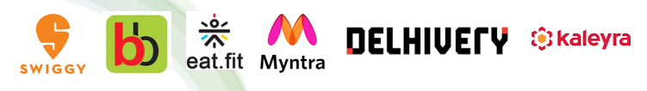

**Market Prospects**

There is a demand for an open, sensible, and secure routine commuting option as the city works back from COVID-19. In Bengaluru, a 10-km distance often takes more than hours to go due to the development of on-demand taxi and auto-rickshaw welcome administrations with options like pool have made daily drive tiny, four-wheeler journeys are a time-consuming concern. Bike taxis have become more prevalent over the past several years in major cities like Bengaluru and Gurugram to address the time problem associated with a step-by-step journey to work. Nevertheless, very few of these bike taxi start-ups have suffered at the hands of established heavyweights; only a few of the newest businesses in the bike taxi sector are built for both suffering and success. Rapido is one such plan.

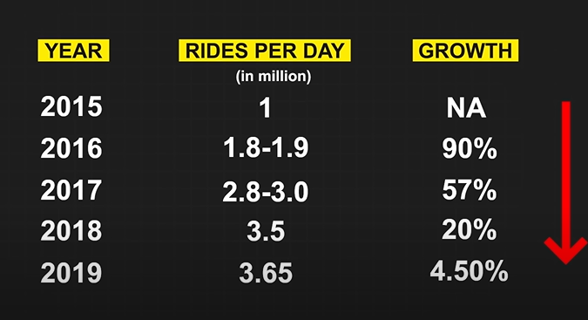

Motorbikes are so prevalent that they are the answer to India's never-ending problems with congested streets, confined open cars, and a subpar last-mile network. It's also the reason why a ton of bike taxi aggregators have started flooding the Indian market in the wake of the success of services like Go-Jek and Grab in the commercial sectors throughout Southeast Asia.

**SWOT Analysis**

**Strengths-**

Rapido provides affordable & quickest commute rides to consumers. It is a User-friendly app with multiple languages and speed tracking for captains. It has a low burn rate and hence a huge leet of riders. It is marketed as a vehicle pooling on a cost-sharing basis instead of bike taxi to evade regulatory hurdles. The user interface of Rapido is much more engaging and easier to use. It is very affordable and provides quick service.

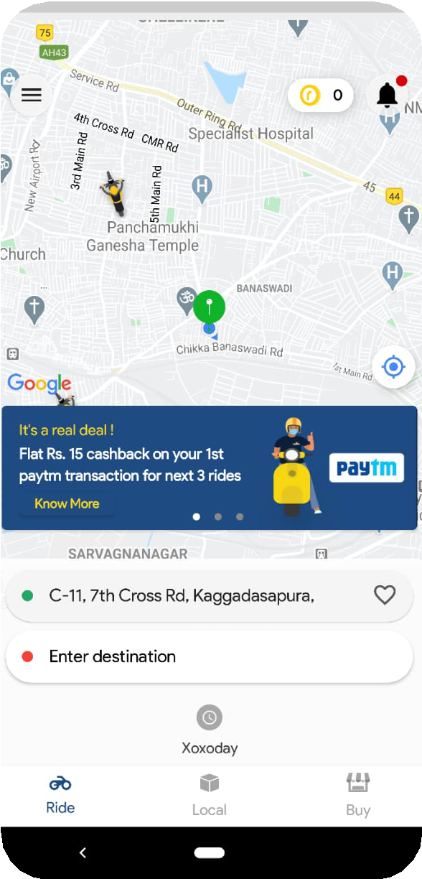

**Weakness-**

There’s a lack of appreciation for bikes as the quickest commute. Due to several threatening cases, the bike is not considered a safe or comfortable ride. The less professional etiquette of Captains is also one of the factors that discourage the consumers.

**Opportunities-**

They identified the lack of a ride sharing service in the low-ticket segment. While OLA and Uber were great for cab services, the normal cost of rides ranges between Rs 200- Rs400 so there was a huge demand for the 200 and below ticket size segment.

There is a huge market of two wheelers in India which was very underutilized (220 million Bike owners and 20 % of them are either unemployed part time workers or students and average bike utilization per day is about 18 %). Rare seats of 80% of the bikes on roads are vacant.

Public transportation in India is slow and does not cover important locations as frequently as required. Due to crowded roads, there is a waste of a lot of time and with two-wheelers it becomes easy to navigate through both traffic and traffic rules.

Opportunities for female drivers- Nearly 15% of Rapido users are women who prefer to have a female driver and Rapido does hire women captains to make their living easier and happier. Many women disclosed Rapido bikes are much safer than uber, ola taxis. Safety concerns of women in public transportation. According to research, 91 percent of women felt that public transport is unsafe. Women often face sexual harassment, aggression/violence, teasing and many other forms of unwelcome behavior in public transport. One-third of female ‘other workers’ in Indian cities walk and cycle to their place of work and are captive users who will shift to other modes of transport with increasing incomes. Similarly, around 2 million women walk 2-5 kilometers every day, distances that could be covered in half the time by cycling.

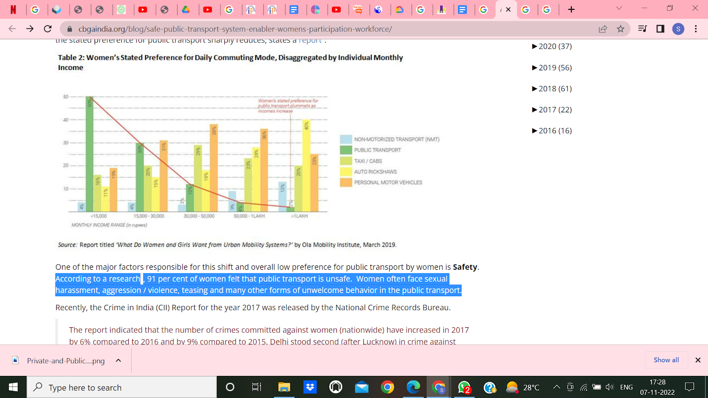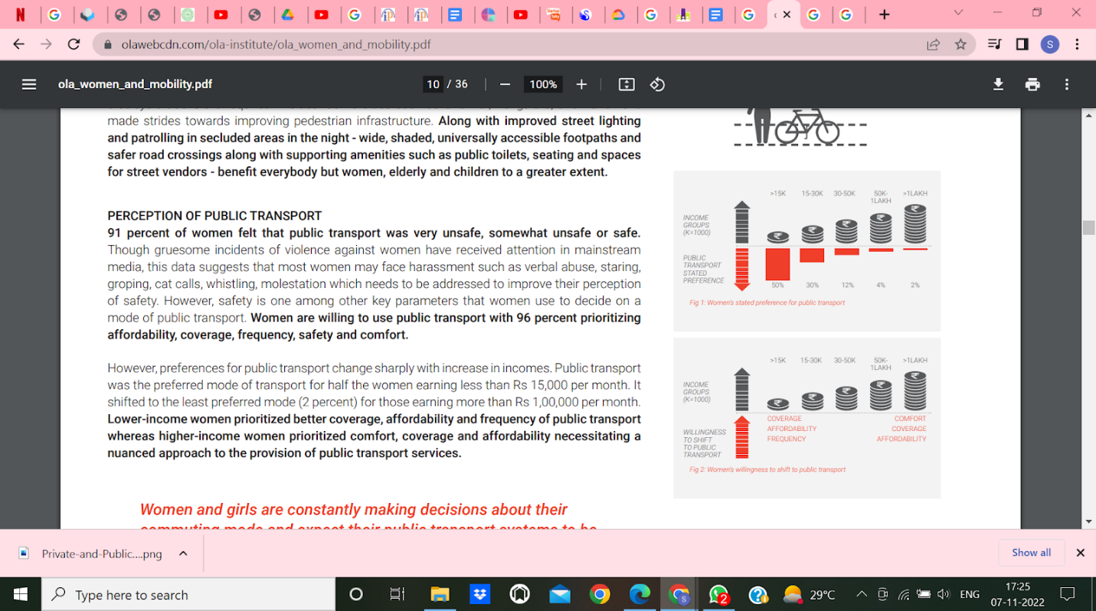

As from the data there are currently 220 million bike users in India out of which 20% are unemployed, students, etc. Rapido can extend its business in this segment providing easily accessible rides to the customers. Moreover, it can enlarge their market in tier-2 and tier-3 cities of India.

**Threats-**

With emerging competitors in the bike taxi segment, it will be incredibly challenging for Rapido to compete in the existing market.

Rising fuel prices and strict government policies toward safety measures

There are situations where the consumer would not get protective helmets or have grievances about the captain. Many individuals were vigilant that bike rides were unsafe. The bike-taxi application Rapido driver threatened, robbed, and stripped a 30-year-old engineer from Chennai. Taxi drivers often build personal relationships with riders and request them to cancel the ride on the app to bypass the commission that the company would charge on every trip completed via its app. 36.5 million people in India, which is 18% of the population, travelled by public transport. (Bus, train, tempo, auto, taxi, water transport) daily. Resistance from these local public transport operators restricts the market growth of Bike taxi Services.

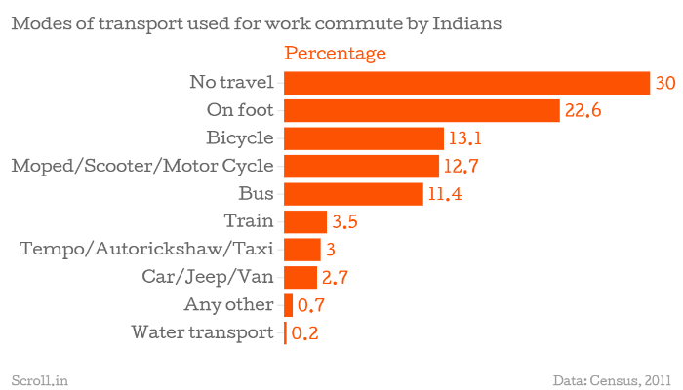

From the survey conducted by our group, 20.3% of the population feels bike taxi segment is not a women friendly service. Women are the potential customers and will constitute a great percentage. If the perception of not being a women friendly service does not go from the minds of people, it will be a threat to the company. 41.5 % of the population complains about frequent cancellation of rides by the drivers

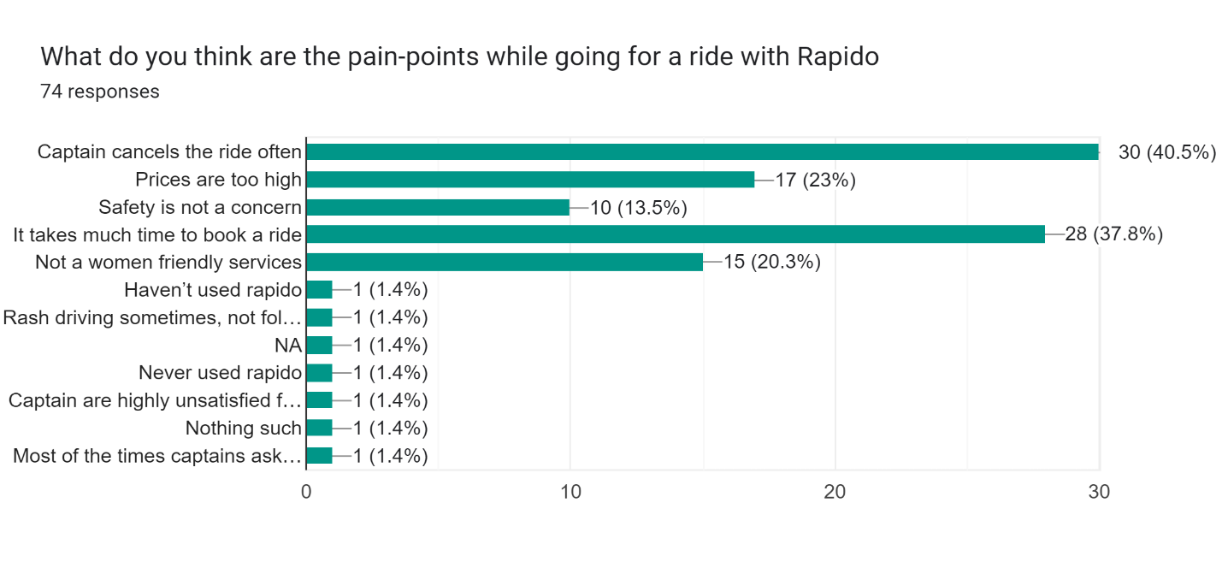

**Competitors**

Bounce, VOGO, Bikxie, Snapbikes, Yulu, Drivezy, ONN, WHEELSTREET, RB (Royal Brothers), and Book My adv.com has been rounded up as the top competitors for Rapido. Among these Yulu is the top competitor of Rapido in terms of cost, availability, and reliability. As you need to book a ride on Rapido this is not the case with Yulu. There are Yulu zones available in Tier 1 cities where you can directly pick up electric scooty or cycle according to your need and can park at the destination zone where you want to end your trip. Yulu is much cheaper and more accessible than Rapido. Rapido needs to study this competitor and should come up with solutions before Yulu expands on a large scale.

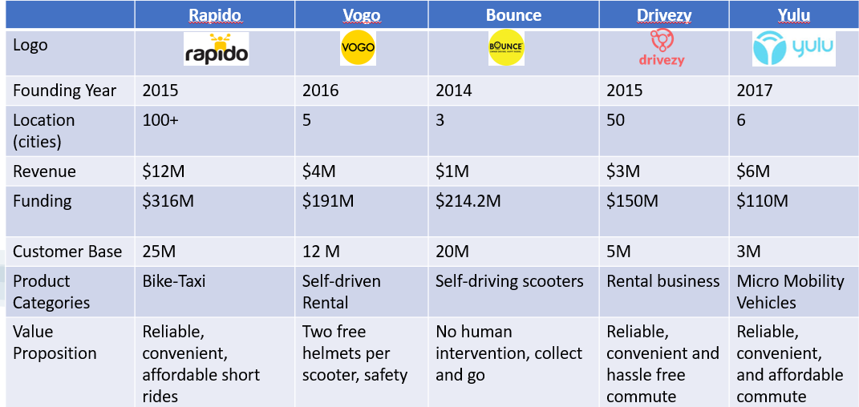

**Fundings**

Recently TVS also went into strategic partnership with Rapido for mutual benefits. Today Rapido’s funding rests at 391 million USD. Rapido also went into logistics partnership with Swiggy.

Launch of a bike cab Several organisations, including former Google India executive Rajan Anandan and Hero MotoCorp Executive Pawan Munjal, have started to financially support Rapido. The resources were delivered for Rapido to expand into various cities and build up the group. Rapido secured an unknown amount in pre-Series A funding in April 2017, with the support of Pawan Munjal, an executive of Hero MotoCorp Ltd., and Rajan Anandan, the head of Google India. By 2018, the association had raised $6 million in two modifications and was consistently getting paid $1.5 million. In August 2019, it encouraged the most recent round of fundraising. Furthermore, Westbridge Capital-led finance of approximately $58 million was lined up by it. With this money, Rapido should make targeted progress in order to soon appear on 100 major urban networks in India. Westbridge Capital, Nexus Venture Partners, Astarc Ventures, IndiaTechnology Fund, Integrated Capital, Ka Wing Kevin Kwong, Skycatcher, etc. are the important fundraisers for Rapido.

**Working**

It's an app where users can reserve bikes at incredibly affordable prices. It provides a significant opportunity for 2-wheeler owners who have a valid driver's licence to make money during their downtime. This programme even became popular as people in big cities got tired of paying more for shorter distances in cabs. This application's quality is recognised in seven different states and numerous important urban areas, including Bengaluru, Gurugram, Hyderabad, Vizag, Pune, Mumbai, Guwahati, etc. Rapido functions similarly to other taxi booking apps for commuters. Customers must join and enter the pickup and destination places in order to schedule a ride. When the reservation is confirmed, they are given the captain's name, picture, and bike number. Rapido rides can be reserved by employees from 6 am to 12 pm. It costs Rs 15 for the basic toll and Rs 3 for each additional mile. Rapido just launched a distinctive feature for visually impaired people. According to the article, 80–100 people who are blind or visually impaired use the app "regularly at better spots to arrive at their objections."

**Major Marketing Campaigns by Rapido**

 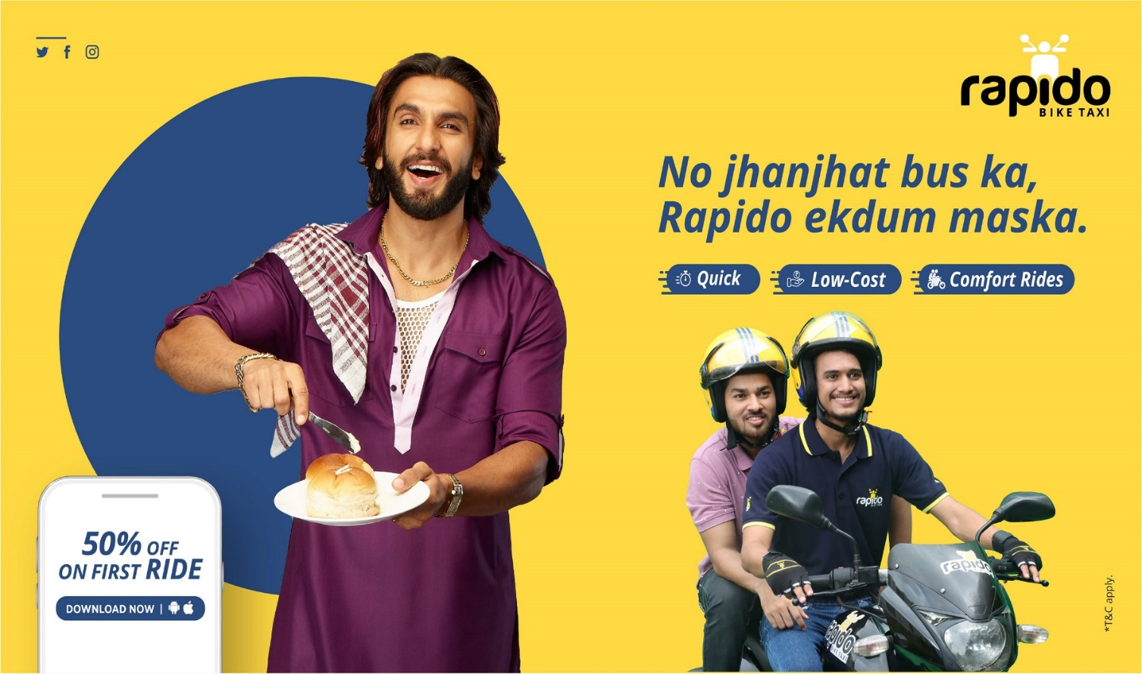

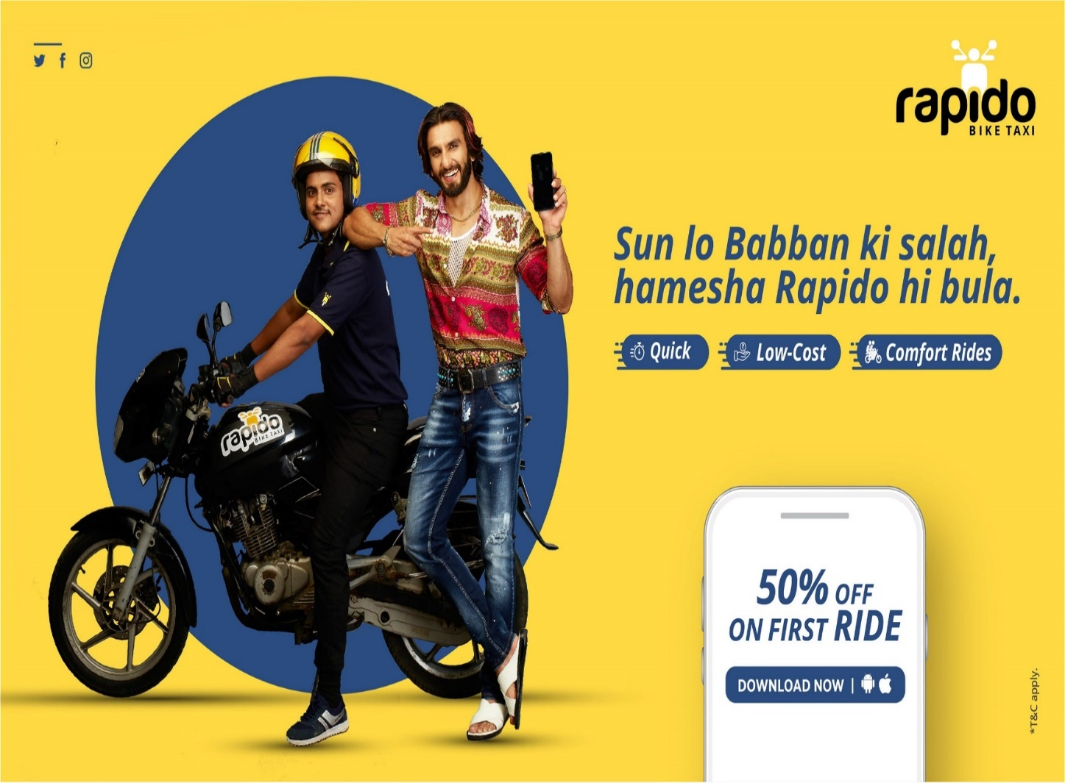

**Market Research**

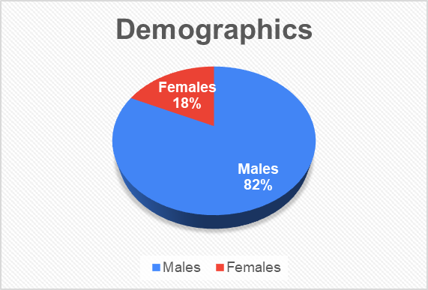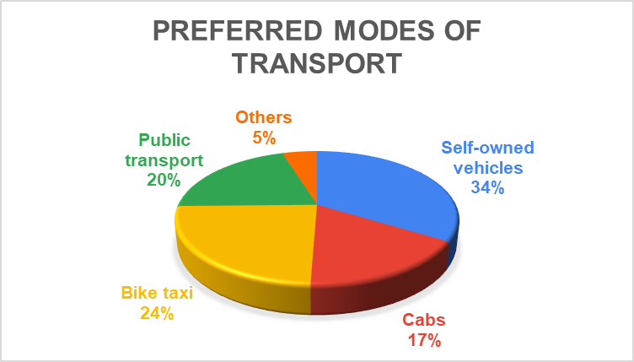

We can see from the customer survey that women’s share is only 20%. There can be multiple reasons like safety, availability, etc. If we increase the number of women captains under Rapido, it will boost the market share of women. From preferred mode of transport survey, we can see that 34% of people choose personal vehicles over another mode of transport. 24% of people prefer bike taxis which is next to personal vehicles. This shows that customers prefer bike taxis over cabs and autos. If we increase the reach of Rapido in tier 2 and tier 3 cities, the market share for bike taxis will rise significantly amount. We evaluated Rapido on the following 6 parameters namely, Safety, Price, Comfortability, Availability, Reliability and User Interface. The 5-star rating shows best while 1 shows worst.

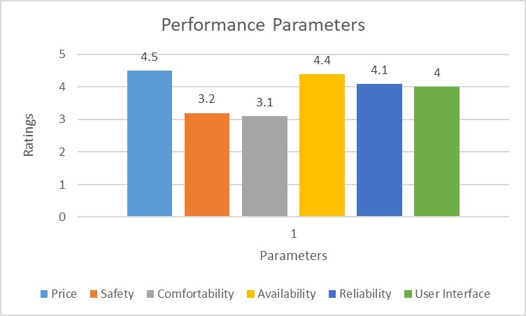

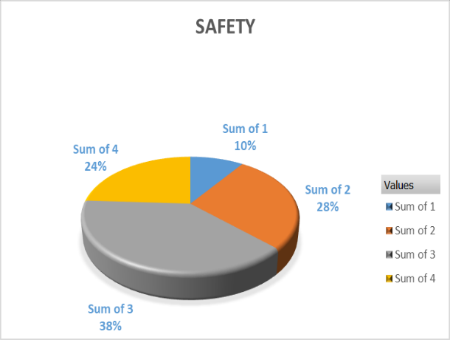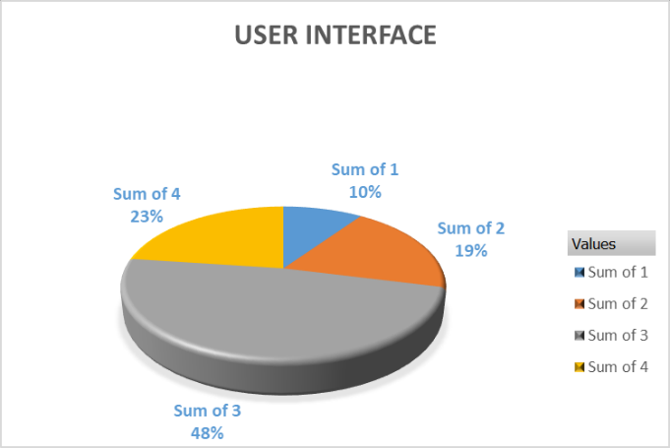

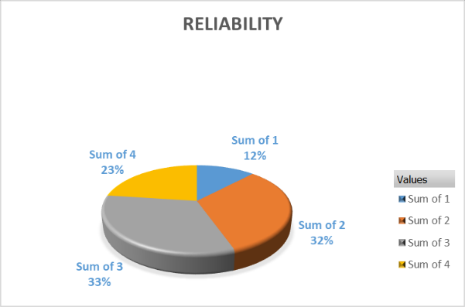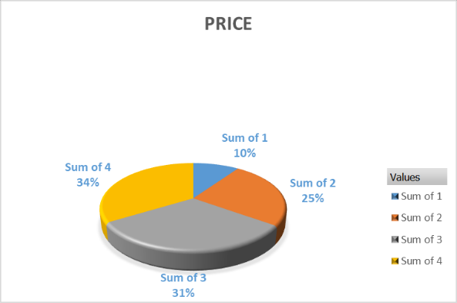

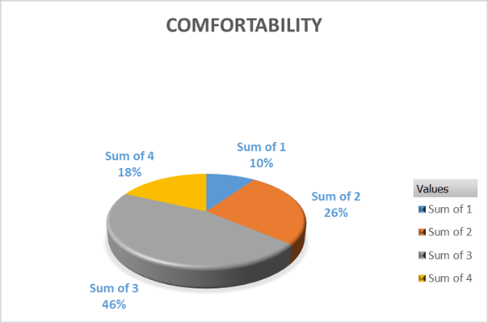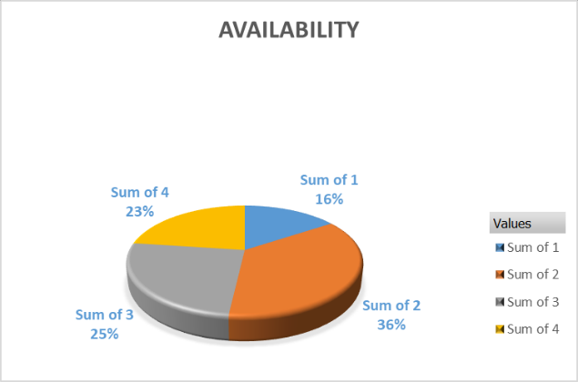

Following can be concluded from the customer survey on performance parameters:

* Customers are highly satisfied with the pricing
* Need to work and promote safety and comfortability measures
* Customers are satisfied with the availability and reliability of Captains
* Easy-to-use application interface

**Challenges**

The biggest challenge Rapido faced was altering the client's perceptions.

*"Bike rides were dangerous, and this alerted many people. So, from day one, we sent out protection. A method to monitor the captain's speed was integrated into the programme. If he ever exceeded a certain speed, he would be disabled”* says Aravind.

There are instances where customers may not receive safety helmets or may have complaints about the captain. Before that, Aravind discovers they took a ton of steps on the captain application to guarantee that captains' onboarding was uniform. Through calls, WhatsApp, or the Rapido app, where the driver transmits details, they boarded. The predicted number of feet on the road for Captains decreased due to this factor. A focused captain care effort made sure that boarding took place online. However, these online bike taxi service providers are having many difficulties in Karnataka. Before, Ola taxis were forbidden and had their permits suspended for a half year. They were made to pay a substantial fine of 15 lakhs. The state government is currently attempting to boycott this application. Gyanendra Kumar, joint commissioner (Enforcement), reported that as of Friday, the public authority has retained more than 170 Rapido bike taxis (5 April 2019). In addition to these reports, COT Narendra Holkar appended a directive to stop bike taxi services in the states to the notice. The administrative center of Rapido has received this notice. According to a report from July 2018, the state's transport authorities has sent letters to Ola and Rapido asking them to discontinue their operations as bike taxis. 3250 people died in roadway accidents in the city, and the number of bike accidents reached its peak. The state transportation division has yet to give these organizations permission to operate bikes as taxis.

The parent company of Ola, Ani technologies, filed an appeal in the Karnataka high court against the state transportation department after encountering similar difficulties in the state because of providing bike taxi services.

Major challenges that needs to be addressed on an immediate basis is to look at the uncaptured market of Tier2 and Tier3 cities. The low entry barrier ensures a high competition in this segment and the hurdle to capture the working female customer base.

**Suggested Solutions**

**Rapido Corp**

* Tapping the office-going employees through ride-sharing and earning opportunities
* Working professionals as ‘Rapido-Host’
* Auto-debit and multiple payment options through wallet due to daily use.

**Self-drive Bike Rental**

* Venturing into the self-drive model in top tourist locations
* Acquiring major startups and making it a successful business model
* Self pick-up and drop services, with minimal manual intervention – Targeting Youth

Rapido can target fast-growing tier 2 cities like Nashik, Ajmer, Durgapur, etc. (Market Penetration). For the tier-2 cities it will act as a pioneer in this segment and has a lead over its competitors. These cities have major working people, mid-class segment who tries to save money and time. Introducing and capturing these market can be truly promising and aspiring.

Rapido can work and strategise its marketing to break gender-stereotype and include female captains. As per our market survey it had been seen that 20.3% of the population believes that the bike taxi segment is not a women friendly service and 13.5% of the junta believes that safety is a major concern. To solve this problem Rapido can launch special marketing programs (Product Development) to capture the market for female riders and female customers. This will give financial independence to women and can act as an additional source of income for them.

To take care of the female customers who prefers to have a female captain instead of male, Rapido can provide an option to select Female captains for female customers. We have seen through various surveys and personal conversations, we understood that more female customers will turn up with bike-taxi instead of fancy, expensive cabs only if it allowed and provided more female captains.

Apart from all the above, Rapido can tune in to offering more robust offers to its daily commuters. One such is ‘Power Pass’ for daily commuters. This will provide additional benefits and perks to customers who uses Rapido on a daily basis for first or last mile connectivity. Power Pass will enable them to get certain discounts and may not have to pay the surge price at times.

Keeping in view of the growing market, we also understand the constant need of our rider’s community. Rapido can target the unemployed students (an exceptionally large segment) to be a part time rider which results in creating part time employment for them and creating an emotional connection with the people. It will also help to provide their services more rapidly and easily. It will help such students to have Rapido as an additional source of pocket money.

**Marketing Strategy in Tier 2**

References

<https://cloud.google.com/customers/rapido>

https://go.appsflyer.com/rs/108-AVT-732/images/AppsFlyer-Rapido-CaseStudy_122020.pdf

<https://www.jmra.in/html-article/13795>

<https://yourstory.com/2020/09/ys-learn-5-essential-factors-rapido-mvp-product-scale>

<https://www.rapido.bike/>

<https://www.rapido.bike/Press>

<https://economictimes.indiatimes.com/topic/Rapido>